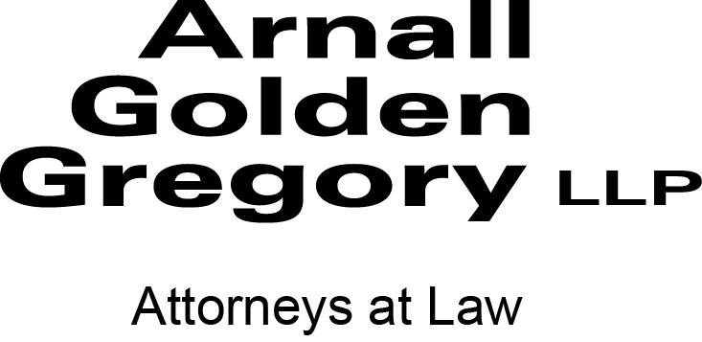
Media contact: Kevin Duffy
404-873-8131, kevin.duffy@agg.com

PRESS RELEASE

Court Decisions Affecting Lenders Discussed at Arnall Golden Gregory Breakfast Briefing

ATLANTA – Attorneys from Arnall Golden Gregory, along with Georgia Bankers Association President Joe Brannen, discussed recent court decisions affecting lenders at the breakfast briefing “Hot Topics for Bank Executives and Credit Officers.”
Leading off the discussion was last summer’s Georgia Supreme Court decision in FDIC v. Loudermilk concerning bank directors’ and officers’ exposure to liability under Georgia’s “business judgment rule.”
Arnall Golden Gregory litigator Edward Marshall explained the court ruled that directors and officers are protected from ordinary negligence claims about the wisdom of a decision, but are at risk if the process that led to the decision was unreasonable.
Mr. Marshall said the takeaways from the court decision are these:
- Establish written procedures for all decision-making processes
- Follow written guidelines
- Consult with advisors – accountants, lawyers, etc.
- Make decisions by committee
- Document everything, focusing on the basis for decisions
He pointed out that plaintiffs’ attorneys will be zeroing in on decision-making processes in their litigation against directors and officers.
AGG real estate litigator James Gober remarked that a process that is overly detailed rather than simple increases negligence risk. Mr. Marshall added that using flexible language in rules – “should” rather than “will” or “must” – is preferred.
Mr. Brannen commented that the GBA is waiting to see how the court decision will affect bank litigation. He said bank directors’ liability exposure raises the question of what is the proper role of a director? Should directors be involved in loan approval?
Another topic of discussion was “secret liens,” led by bankruptcy attorney Sean Kulka. Secret liens are unrecorded and typically involve unpaid utility bills. Foreclosure does not extinguish utility liens because, like tax liens, they are afforded heightened priority status over recorded liens under Georgia law.
Unpaid utilities can affect the value of a commercial property in a foreclosure sale even if the outstanding charges do not create a right to a utility lien because the charges were incurred by a non-owner, Mr. Kulka said. For example, a water services provider may refuse to serve a commercial property that the bank is trying to sell because of unpaid bills of a non-owner such as a tenant or receiver.
Mr. Kulka advised lenders to demand that utility-lien exceptions in lender title insurance be removed. He said Georgia law is ambiguous as to what the term “utility” encompasses and whether certain statutory limitations that are expressly applicable to water service providers are also applicable to other types of utility service providers. Mr. Kulka indicated that legislative reform is needed in this area.
Another bankruptcy partner, Michael Holbein, discussed the Georgia Court of Appeals decision in HWA Properties, Inc. v. Community & Southern Bank concerning guarantor liability on an unconfirmed foreclosure deficiency. Noting that the court’s ruling is based on a fairly specific waiver in the guaranty at issue, Mr. Holbein proposed that lender’s consider adopting that language, as well as reviewing older loan files for actionable post-foreclosure guarantor claims.
Arnall Golden Gregory’s Financial Institution Industry Team combines the expertise of attorneys working in Real Estate, Commercial Lending, and Corporate and Securities.

ABOUT ARNALL GOLDEN GREGORY LLP

Arnall Golden Gregory, with more than 150 attorneys in Atlanta and Washington, DC, employs a “business sensibility” approach, developing a deep understanding of each client’s situation in order to find a customized, cost-sensitive solution. A past honoree on The National Law Journal’s prestigious Midsize Hot List, the firm advises on corporate, litigation, regulatory and immigration matters for numerous industries, including real estate, business services, healthcare, life sciences, logistics and transportation, franchising, information services, energy, and manufacturing. AGG is a solutions partner that subscribes to the belief “not if, but how.”

